**A MINI PROJECT REPORT**

**ON**



**FLIGHT RESERVATION SYSTEM**

**Advanced java (CAN604)**

**Submitted in partial fulfillment of the requirements for the award**

**Degree of Master of computer application**

**By**

**SHASHANK BHARDWAJ Submitted to:-**

**(SAPID. 1000024713) MR. Ravi Shankar jha**

**Branch:-MCA Assistant professor**

**( School of computing**

**Dit university)**

**DIT UNIVERSITY**

**INSTITUTE OF SCHOOL OF COMPUTING**

**(DEEMEDTOBEUNIVERSITY)**

**Accredited withGrade“A”byNAAC**

**APRIL-2025-26**

# DEPARTMENT OF SCHOOL OF COMPUTING

**BONAFIDECERTIFICATE**

This is to certify that this Project Report is the bonafide work of **SHASHANK BHARDWAJ (SAPID:-1000024713)**who carried out the project entitled**“ FLIGHT RESERVATION SYSTEM”** under my supervision

**InternalGuide**

**MR. Ravi Shankar jha**

**Assitant professor**

**School of computing**

**DIT UNIVESRITY, Dehradun (uttarakhand) india:-248009**

**Submitted for Vivavoce Examination heldon**

**InternalExaminer ExternalExaminer**

# DECLARATION

I**, Shashank Bhardwaj (SAP ID.1000024713)**here by declarethattheProjectReportentitled

**“FLIGHT RESERVATION SYSTEM”** done by me under the guidance of

**MR .Ravi Shankar jha (assistant professor of school of computing)** is submitted in partial fulfillment of the requirements for the award of master of computer application / Technology degree in Computer Science.

**DATE:**

**PLACE: SIGNATUREOFTHECANDIDATE**

**ACKNOWLEDGEMENT**

I am pleased to acknowledge my sincere thanks to **Board of Management** of **DIT UNIVERSITY** for their kind encouragement in doing this project and for completing it successfully. I am grateful to them.

I convey my thanks to **mrs. Bharti mam.,** HOD(Head of department),School of Computing

.

I would like to express my sincere and deep sense of gratitude to my Project Guide

**MR. Ravi Shankar jha sir**., for his valuable guidance, suggestions and constantencouragementpavedwayforthesuccessfulcompletionofmyprojectwork.

I wish to express my thanks to all Teaching and Non-teaching staff members of the Department of Computer Science who were helpful in many ways for thecompletion of the project.

**ABSTRACT**

Thepurposeof this section is tostate theGoalandObjectives of theSoftware Project.

TheprojectpresentedhereistheAirlineReservationSystem.

Airlinereservationssystemisanintegratedpassengerprocessingsystem,includinginventory, fares, ticket-less operations and credit card transactions. All communications are via TCP/IP network protocol enabling the using of both intranet and internet communications worldwide.

The solution includes several standard items, which are combined to provide an integrated solutionwithinterfacestootherbusinesssystems.Thesystemisbasedonopenarchitecture, using industry standard equipment and software. The open natureof VRSallows the addition of new systems and features, ensuring that the VRS system can be adapted to keep up with the changing requirements of the airline business.

TheVRSsuiteofsoftwareincludesthefunctionsof

* Reservations
* Flightinventory
* Fares

All user/agents are allocated a SINE code, which is used during sine-on and then appended to all transactions carried out by the agent for security purpose. Different security levels may be assigned so that different agents can access different areas of the system and also different records in the case where a travel agent is only allowed to review PNR’s that have been created by that agency.

The flights may be specified within a particular date range and may be used to display different classes of service and different fares within a specific seating class. Sell from availabilitywhenithasbeendisplayedandasimpleentryisusedtosellseats.Adirectsale may be made using a long hand entry if the flight details are fully known.

**CONTENT**

|  |  |  |
| --- | --- | --- |
| **CHAPTER NO** | **TITLE** | **PAGE NO.** |
|  | **ABSTRACT** | **v** |
|  | **LIST OFFIGURES** | **vii** |
|  | **LIST OFTABLES** | **ix** |
|  | **LIST OF ABBREVIATIONS** | **x** |
| **1** | **INTRODUCTION** | **1** |
| **2** | **LITERATUREREVIEW** | **2** |
| **3** | **AIMANDSCOPEOFPRESENTINVESTIGATION** | **4** |
|  | 3.1AIM | **4** |
|  | 3.2SCOPE | **4** |
| **4** | **METHODOLOGY** | **5** |
|  | 4.1SYSTEM ANALYSIS | **6** |
|  | 41.1EXISTINGSYSTEM | **6** |
|  | 4.1.2PROPOSEDSYSTEM | **7** |
|  | 4.1.3PROBLEMSTATEMENT | **7** |
|  | 4.2 OBJECTMODELLING | **8** |
|  | 4.2.1IDENTIFICATIONOFOBJECTCLASSES | **8** |
|  | 4.2.2IDENTIFICATIONOFATTRIBUTES | **9** |
|  | 4.2.3DYNAMIC MODELLING | **11** |
|  | 4.2.3.1PREPARINGASCENARIO | **11** |
|  | 4.2.3.2STATEDIAGRAM | **12** |

|  |  |  |
| --- | --- | --- |
|  | 4.2.4FUNCTIONALMODELLING | **13** |
|  | 4.2.4.1DATAFLOW DIAGRAM | **13** |
|  | 4.3SYSTEM DESIGN | **15** |
|  | 4.3.1TABLES | **16** |
|  | 4.3.1.1DATABASEDESIGN | **16** |
|  | 4.3.1.2TABLEDESCRIPTION | **17** |
|  | 4.4IMPLEMENTATION | **20** |
|  | 4.4.1SOFTWAREREQUIREMENTS | **20** |
|  | 4.4.2HARDWAREREQUIREMENTS | **21** |
|  | 4.5TESTING | **22** |
| **5** | **RESULTSANDDISCUSSION** | **23** |
| **6** | **CONCLUSIONANDFUTUREWORK** | **24** |
|  | **REFERENCES** | **25** |
|  | **APPENDIX** | **27** |
|  | A.SAMPLECODE | **27** |
|  | B.SCREENSHOTS | **34** |

**LISTOF FIGURES**

|  |  |  |
| --- | --- | --- |
| **FIGURE NO.** | **FIGURENAME** | **PAGE NO.** |
| 4.2.1 | IDENTIFICATIONOFOBJECTCLASSES | **8** |
| 4.2.3.2 | STATE DIAGRAM | **12** |
| 4.2.4.1 | DATAFLOW DIAGRAM | **13** |

**LISTOFTABLES**

|  |  |  |
| --- | --- | --- |
| **TABLENO.** | **TABLE NAME** | **PAGE NO.** |
| 4.2.2 | IDENTIFICATIONOF ATTRIBUTES | **9** |
| 4.3.1.2 | TABLE DESCRIPTION | **17** |

**LISTOF ABBREVATIONS**

|  |  |
| --- | --- |
| **TCP** | TRANSMISSIONCONTROLPROTOCOL |
| **IP** | INTERNET PROTOCOL |
| **OMT** | ONBOARDMAINTENANCETERMINAL |
| **DFD** | DATAFLOW DIAGRAM |
| **LRS** | LOGICALRECORDSTRUCTURES |
| **LAN** | LOCALAREANETWORK |
| **VRS** | VIDEOCOMRESERVATIONSYSTEM |

**INTRODUCTION**

Flight reservation systemisanintegratedpassengerprocessingsystem.This system includes:

* Fares
* Inventory
* Enquiry
* Reservations

InthissystemallthecommunicationsareviaTCP/IPprotocolusingboththe Intranet and Internet communications worldwide.

TheAirlineReservationsystemhasthefollowingModules:

**Userregistrationmodule:**

Thismoduleishelpfulfortheregistrationofthenewcustomer.

**Login module:**

Thismoduleperformstheloginoftheregisteredcustomer.InthismoduleCustomer-id and password is verified.

**Reservationmodule:**

Thismoduleperformsthereservationofthetickettotheregisteredmodule.

**Cancellationmodule:**

Thismoduleperformsthecancellationofthereservedticket.

# LITERATURESURVEY

## Web Service-based Automata Testing: A Case Study on Online Airline Reservation

**Authors: Temitope Betty Williams ; Amir Rizaan Abdul Rahiman ; Izuka Joseph, 2020 International Conference on Computer Science and Its Application in Agriculture (ICOSICA)**

Thefocusofthisstudyistoshowandevaluatehowthewebservicescanefficiently be utilized for online airline reservation system by utilizing the finite automata state machine. A finite automaton is a straightforward machine that has a finite numeral state which could be either an accepting state or rejecting state. It is being used to recognize thepatternseitheracceptorrejectbytakingstringsofsymbolsasinputandchangingits stateaccordingtorulesofthemachine(e.g.,statefunction)untiltheanticipatedsymbols are created

## The role of ICT Reservation Systems for operational management of air transportation companies

**Authors: Okulski ; Radoslaw Robert , 2009 Fourth International Conference on Computer Sciences and Convergence Information Technology**

Airlines have been applying on-line technologies for booking and ticketing for decades. Starting from the early 1980s, the computer reservation system (CRS) has played a very important role in the provision of airline services. Zheng-Yi, Fang-Yuan, & Yu-Hern (2003) Consequently, the technologies data communication network had been organized. Moreover, CRS was sold to various markets around the world. Finally, after 1990, there was the Computer Reservation System, which was compatibly connected with a revenue management system. With some other added functions, car rental and hotel booking systems were introduced.

## WhatAirlineReservationSystemsTellUsabouttheFutureof EHRs

**Authors:SheilaSherlock;WilliamG.Chismar ,Proceedingsofthe39thHawaii International Conference on System Sciences – 2006**

In theairline industry, the justification for adoption of computerizedreservation systems(CRSs),shiftedfromoperationalefficiency,tomarketingstrategiestorecoup investment, to competitive advantages of essential business tools. This progress contributed to fundamental changes in the structure of the industry. In large part, networkexternalitiescreatedbythesesystemsandthediscrepancybetweenwhopaid for the systems, and who reaped the financial benefits drove these changes.

1. **TheoryofDialogueStructurestoHelpManageHuman-ComputerInteraction Authors: David L. Sanford, Associate Member ;John w. Roach, Member, IEEE**

# IEEETRANSACTIONSONSYSTEMS,MAN,ANDCYBERNETICS,VOL.18,NO. 4, JULY/AUGUST 1988

The principles of human communication underlie all modes of interaction and therefore are fundamental to designing effective interfaces. In particular, we present an extension to human communication theory that allows us to create a natural languageinterfaceusinghumancommunicationprinciples.Whenpeopleinteract,they use “metacommunication” to help manage the shared communication context. Using metacommunication partially accounts for the enormous range of expressiveness in natural languages.

## AirlinesReservations.Systems

**Authors:JohnR.Knight, Procedizgs ofthe IEEE,VOL. 60, KO. 11, NOVEMBER 1972**

The structure of the system is described-agent terminal area, communications facilities, and central site. Lessons learned in the design, development, testing, implementation, and tuning of two generations of systems are discussed. These discussions include initial system design, simulations and systems measurement tools, systemsstabilityandreliability,serialprocessing,parallel-ormultiprocessors,splitfront- end back-end processing, storage hierarchy, standard and special communications disciplines, and flexibility versus performance.

# AIM

The main objective is to reduce the mistakes which creep up in manual systems. It provides good level of security so it takes care of the user’s safety concerns as well. Passengers can access the whole list of all the flights available on different routes with theirtimingsandfarebothforeconomyandbusinessclasses.Onecancomparethebest deals for them and book a flight accordingly. When the passengers enter all the details thesoftwarehelpsthemtofindallavailableflightsandalsoinformationifthereareseats available on that particular flight. The manual work is thus reduced and the chances of errors are reduced to minimum.

# SCOPE

* + - Thissoftwarehelpspassengerstolookupflightsbetweentwopointswhichcan be domestic or international.
    - The passengers can find and book tickets for flights through this software. Developedinjava,itisfairlyeasytousesoftwarehavingauser-friendlyinterface
    - Themainobjectiveistoreducethemistakeswhichcreepupinmanualsystems. Itprovidesgoodlevelofsecuritysoit takescareoftheuser’ssafetyconcernsas well.
    - One can compare the best deals for them and book a flight accordingly. When thepassengersenterallthedetailsthesoftwarehelpsthemtofindallavailable flights and also information if there are seats available on that particular flight.
    - Themanualworkisthusreducedandthechancesoferrorsarereducedto minimum.

# METHODOLOGY

OMTconsistsofbuildingamodelofanapplicationdomainandthenadding implementation details to it during the design of a system.

TheMethodologyhasthefollowingstages:

1. **Analysis:** The analysis model is a concise, precise abstraction of what the desired system must do, not how it will be done.
2. **System Design:** The system designer makes high-level decisions about the overall architecture,duringsystemdesign;thetargetsystemisorganizedintosubsystemsbased on both the analysis structure and the proposed architecture.
3. **Object Design:** The object designer builds a design model based on the analysis model but containing implementation details. The designer adds details to the design model in accordance with the strategy established during system design.
4. **Implementation:**Theobjectclassesandrelationshipsdevelopedduringobjectdesign are finally translated into a particular programming language, database, or hardware implementation.

TheOMTmethodologyusesthreekindsofmodelstodescribea system.

1. **ObjectModel**:Theobjectmodeldescribesthestaticstructureoftheobjectsina system and their relationships. The object model contains object diagrams.
2. **Dynamic Model:** The dynamic model describes the aspects of a system that change over time.The dynamic model contains state diagram
3. **FunctionalModel:** The functional model describes the datavalue transformations within a system. The functional model contains data flow diagrams.

# SYSTEMANALYSIS

### EXISTINGSYSTEM

Airline Reservation System is a System including Inventory, Fares, Enquiries, Reservations etc. All user/agents are allocateda SINE code which is used during sine- on and then appended to all transactions carriedout by the agent for security purpose.

***IthasthefollowingDis-advantages****:*

* + - * Reservationsdoesnotsupportupto1year.
      * Accessingandupdatingthesystemisslow.
      * Itisa filebased processing.

### PROPOSEDSYSTEM

Usingthedistributedtechnologywecanhandletheseproblemseasily.Ingeneral adistributedprocessmeansthataprograminexecutionmakesuseofresourcesinother machine.ThetwotechnologiesfordistributedprocessingavailableareJ2EEand.NET. In the “Airline reservation system” J2EE is used for managing distributed systems. So thateveniftheAirlinesystemhaslotofbranchesandtheyarelocatedatdifferentplaces

,wecanhandlethemanagementofserviceandguarantee.

Theproposedsystemfortheproblemis“Airlinereservationsystem”,awebbased system that allows online reservations. The system is divided into three layers namely presentation layer , business layer and data layer. The presentation layer is at the client side.Atserverside,businesslayeranddatalayerreside.Thesystemrequiresaserver side technology for its implementation. J2EE platform is chosen for implementing the system. At server sideServlet plays the role for business layer and JDBC for the data layer.

***Ithasthefollowingadvantages.***

* + - * Reservationsaresupportedupto1year.
      * AccessingandUpdatingthesystemisFast.
      * ItisImplementedusingtheconceptsofRDBMS.

### 4.1.3.PROBLEMSTATEMENT

The objective of the project is to design and implement the software which helps the Airline Systememployeesto issuereservation tickets forvariousAirflightsandmaintain the records of various passengers and provide quick services to the passengers. It provides the following services:

* ReservationandCancellationoftheAirlinetickets. Maintains the passengers’ records.
* Reportsaboutthedaily transactionsoftheAirlineSystem.
* QuickResponsetothepassengers.
* AutomationandintegrationofAirlinesystemfunctions.
* Higherproductivityandeffectivemanagement
* Securityandprotectionofconfidentialdata.
* Transactionmanagementandrouting.

### OBJECTMODELLING

Theobjectmodeldescribesthestructureofobjectsinasystem.Theiridentity,their relationships to other objects, Their attributes, and their operations. The object model provides the essential framework into which the dynamic and functional models can be placed.

Ourgoalinconstructinganobjectmodelistocapturethoseconceptsfromthereal world that are important to an application. The object model is represented graphically with object diagrams containing object classes. Classes are arranged into hierarchies sharingcommonstructureandbehaviourandareassociatedwithotherclasses.Classes definetheattributevaluescarriedbyeachobjectinstanceandtheoperationswhicheach object performs or undergoes.

### IDENTIFICATIONOFOBJECT CLASSES

The first step in constructing an object modelis to identify relevantobject classes from the application domain. Objects include physical entities, such as houses, employees, and machines, as well as concepts, such as trajectories, seating assignments, and payment schedules. All classes must make sense in the application domain;avoidcomputerimplementationconstructs,suchaslinkedlistsandsubroutines. Not all classes are explicit in the problem statement; some are implicit in the application domain or general knowledge.

**AirlineReservation System**

**Reservationmodule**

**Flight operation**

**Flight cancellation**

**Userregistration**

**New customer**

**Customer**

**Bankserver**

**Registration_info**

**Login_info**

**Reservation_Info**

**Flight_info**

**Price_info**

**Transaction_info**

**Airport_info**

### IDENTIFICATIONOF ATTRIBUTES

Attributesarepropertiesofindividualobjects.Attributesshouldnotbeobjects.Use an association to show any relationship between two objects. Attributes usually correspond tonounsto followbypossessivephases. Adjectivesoften represent specific enumerated attribute values. Attributes are less likely to be fully described in the statement of problem. The knowledge must be drawn from the application domain and the real world to find out the attributes. This figure 3.2.2 shows the identification of attributes.

|  |  |
| --- | --- |
| **Class** | **Attributes** |
| Registration_info | FirstName,LastName,Address, ContactNo,City,State,Country, Gender,Email_Id,  Customer_id,password |
| Login_info | Customer_id,password |
| Reservation_info | Customer_id, flight_num, Flight_name,derarture_time, Arrival_time, origin, Destination, Num_of_seats |
| Flight_info | Flight_num, flight_name, Departure_time, Arrival_time, Origin,destination,num_of_seats,  Country_name |
| Price_info | Class,customer_name,  seat_num,price |
| Transactio_info | Credit_num,Credit_type,  Pin_num |
| Airport_info | Country_name,Airport_name |
| Flight_cancellation | Customer_id,Flight_id,origin,  Destination,Flight_name,departure, Arrival,seat_num |

### DYNAMICMODELLING

Thedynamicmodeldescribestheaspectsofasystemthatchangeovertime.The dynamic model is used to specify and implement the control aspects of a system. The dynamic model contains state diagrams. A state diagram is a graph whose nodes are states and whose arcs are transitions between states caused by events.

The dynamic model is insignificant for a purely static data repository. Such as a database. The dynamic model is important for interactive systems. For most problems, logical correctness depends on the sequences of interactions, not the exact times of interactions.

Dynamicmodellingisadescriptionofaspectsofasystemconcernedwithcontrol, including time, sequencing of operations, and interaction of objects.

Followingstepsareperformedinconstructingadynamicmodel.

* Preparescenariosoftypicalinteractionsequences.
* Identifyeventsbetweenobjects.
* Prepareaneventtraceforeach scenario
* Builtastate diagram
* Matcheventsbetweenobjectstoverify consistency.

### PREPARINGASCENARIO

* + - * + Newcustomerentersthesystemandmakestheregistrationandgetsa customer_id.
        + Customerswhoarealreadyregisteredentersthe system.
        + Customermakesthereservationoperationandgetsthe response.
        + Customermakesthequeryfor flightoperations&getsbackthe response.
        + Customermakestheflightcancellationoperationandgetstheappropriate response.

### STATEDIAGRAM

A state diagram relates events and states. When an event is received, the next statedepends on the current stateas well asthe event: A changeofstate causedby an eventiscalledatransition.Astatediagramisagraphwhosenodesarestatesandwhose directedarcsaretransitionslabelledbyeventnames.Astateisdrawnasaroundedbox containinganoptionalname.Atransitionisdrawnasanarrowfromthereceivingstateto the target state: The label on the arrow is the name of the event causing the transition. Figure below shows a state diagram describing the behaviour of Airline Reservation System.



●

* **Enter**

System

do :Enterthe

Operations

FlightOperation

Performs

Reservation

Flight

Cancellation

### FUNCTIONALMODELLING

The functional model shows how values are computed, without regard for sequencing, decisions or object structure. The functional model shows which values depends on which other values and the functions that relate them. The DFD are useful for showing functional dependencies. The functions are expressed in various ways, including natural language, mathematical equations and pseudo code.

Functional Model is a description of aspects of a system that transform values using functions, mappings, constraints and functional dependencies.

Thefollowingstepsareperformedinconstructingafunctional model.

* Identifyinputandoutput values.
* Builddataflowdiagramshowingfunctionaldependencies.
* Describefunctions.
* Identifyconstraints.
* Specifyoptimizationcriteria.

### DATAFLOW DIAGRAM

Data flow diagrams (DFD) depict information flow and the transforms that are applied as data move from input to output. It is the starting point of design phase that functionallydecomposestherequirementspecificationsdowntothelowestleveldetails. Thus a DFD describes what data flows (Logically) rather than how they are processed. So, it does not depend on hardware, software or data structures. It is one of the most importanttoolsusedduring systemanalysis.It isused tomodelthesystemcomponents such as the system process, data used by the process any external that interact if the system and information flows in the system.

***DFD-AirlineReservationSystem:***

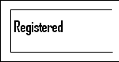

**Performs the**

**operations**

**Reservation**

**Operation**

**AirlineReservation System**

**Selectsthe**

**operation**

**Gets**

**New**

**Customer**

**Enter**

**Customer**

**Generatesthe output**

**Givestothe**

**Customer**

# SYSTEMDESIGN

The problem analysis is the most important phase in any project. Only after knowing precisely what the problem is could we successfully eliminate it. The identificationoftherootproblemisnecessary.Wewereabletodiscusswiththepersonnel of various departments and gather information and we got a clear picture of what the existing problem were and what our jobs was to eliminate them by redesigning a new design.

Design is a multi step process that focuses on data structure, software architecture,Proceduraldetails(algorithmsetc)andinterfacebetweenthemodules.The design processalso translates the requirements into the representationsof the software that can be assessed for quality before coding begins.

Computer software design changes continually as new methods, better analysis and border understanding evolve. Software design is at a relatively early flexibility and quantitative nature that is normally associated with more classical engineering design disciplines. However, techniques for software design to exist criteria for design qualities are available and design notation can be applied.

Once the software requirements have been analyzed and specified, software design is the first of three technical activities- Design code and test that are required to build and verify the software. Each activity transforms information in a manner that ultimately results in validation of the computer software.

The importance of the software design can be started with a single word quality. Design is the place where quality fostered in software development. Design provides us with representations of the software that can be accessed for quality.

Designistheonlywaythatwecanaccuratelytranslateacustomer’srequirements into a finished software product or system. Without design, risk of building an unstable system exists one that will fail when small changes are made. One that may be difficult to test.

Thusthesystemdesignincludesfollowingthreetypesof design:

* **Data Design:** The data design transforms the information domain model created during analysis into the data structures that will be required to implement the software.
* **Architectural Design:** The architectural design defines the relationship among the major structural components of the program.
* **ProceduralDesign:**Theproceduraldesigntransformsstructuralcomponentsinto a procedural description of the software. Source code is generated and testing is conducted to integrate and validate the software.

Thus,systemdesignisasolution,a“howto”approachtothecreationofthenewsystem.

# TABLES

* + - 1. ***DatabaseDesign***

The database design converts the data model developed in logical design to a databasedefinitionthatissupportedbydatabasesoftware. Thefirststepisindependent of the kind of DBMS used. This step converts the conceptual entity relationships model toasetofrecordtypeisknownasthelogicalrecordstructures.(LRS).Thenextdatabase design step converts the LRS to a database definition.

These steps use techniques that depend on the DBMS. DBMS dependent techniques are needed here because different DBMS support different kind of links between the records. Such links are used to retrieve records by following the link from one record to another. Database design depends on the structure supported by DBMS and uses techniques appropriate to these structures.

DBMS dependent design proceeds in two stages. The first step is logical design. LogicaldesigndefinestheDBMSrecordtypesandthelinksbetweenthem.Thenextstep is physical design. This step choosesa physical organization that supports the methods uses to accesses the databases.

* + - 1. ***TableDescription***

***Tablename:Registration_info***

|  |  |  |  |
| --- | --- | --- | --- |
| **FieldDescription** | **Name** | **Type** | **Width** |
| FirstName | FirstName | Varchar | 12 |
| LastName | LastName | Varchar | 12 |
| Customer’sAddress | Adress | Varchar | 16 |
| Customer’sContactNum | ContactNo | Number | 12 |
| Customer’sCity | City | Varchar | 12 |
| Customer’sState | State | Varchar | 12 |
| Customer’sCountry | Country | Varchar | 12 |
| Customer’sGender | Gender | Varchar | 2 |
| Customer’sEmail-Id | Email_Id | Varchar | 12 |
| Customer’sId | Customer_id | Varchar | 8 |
| Customer’sPassword | Password | Varchar | 8 |

***Tablename:Login_info***

|  |  |  |  |
| --- | --- | --- | --- |
| **FieldDescription** | **Name** | **Type** | **Width** |
| Customer’sId | Customer_id | Varchar | 8 |
| Customer’sPassword | Password | Varchar | 8 |

***Tablename:Reservation_info***

|  |  |  |  |
| --- | --- | --- | --- |
| **FieldDescription** | **Name** | **Type** | **Width** |
| Customer’s Id | Customer_id | Varchar | 8 |
| Flight’sNumber | Flight_num | Varchar | 12 |
| Flight’sName | Flight_name | Varchar | 12 |
| DepartureTime | Departure_time | Time |  |
| ArrivalTime | Arrival_time | Time |  |
| OriginPlace | Origin | Varchar | 16 |
| Destinationplace | Destination | Varchar | 16 |
| NumberofSeats | Num_of_seats | Number | 4 |

***TableName:Flight_info***

|  |  |  |  |
| --- | --- | --- | --- |
| **FieldDescription** | **Name** | **Type** | **Width** |
| Flight’sNumber | Flight_num | Varchar | 12 |
| Flight’sName | Flight_name | Varchar | 12 |
| DepartureTime | Departure_time | Time |  |
| ArrivalTime | Arrival_time | Time |  |
| OriginPlace | Origin | Varchar | 16 |
| Destinationplace | Destination | Varchar | 16 |
| NumberofSeats | Num_of_seats | Number | 4 |
| CountryName | Country_name | Varchar | 12 |

***TableName:Price_info***

|  |  |  |  |
| --- | --- | --- | --- |
| **FieldDescription** | **Name** | **Type** | **Width** |
| ClassName | Class | Varchar | 12 |
| Customer’s Name | Customer_name | varchar | 14 |
| Seat Number | Seat_num | Number | 4 |
| PriceOf ticket | Price | Number | 4,2 |

***Tablename: Transaction_info***

|  |  |  |  |
| --- | --- | --- | --- |
| **FieldDescription** | **Name** | **Type** | **Width** |
| Creditcardnumber | Credit_num | Varchar | 8 |
| Credircardtype | Credit_type | Varchar | 8 |
| Pin Number | Pin_num | Number | 6 |

***Tablename:Airport_info***

|  |  |  |  |
| --- | --- | --- | --- |
| **FieldDescription** | **Name** | **Type** | **Width** |
| CountryName | Country_name | Varchar | 14 |
| AirportName | Airport_name | Varchar | 14 |

***Tablename:Flight_cancellation***

|  |  |  |  |
| --- | --- | --- | --- |
| **FieldDescription** | **Name** | **Type** | **Width** |
| Customer’s Id | Customer_id | Varchar | 8 |
| Flight’sNumber | Flight_num | Varchar | 12 |
| OriginPlace | Origin | Varchar | 16 |
| Destinationplace | Destination | Varchar | 16 |
| Flight’sName | Flight_name | Varchar | 12 |
| DepartureTime | Departure_time | Time |  |
| ArrivalTime | Arrival_time | Time |  |
| SeatNumber | Seat_num | Number | 4 |

# IMPLEMENTATION

* + 1. **SOFTWAREREQUIREMENTS**

## Server

WeblogicserverisusedforrecordingdatathroughOracle8i.

## Compatibleoperatingsystem

* + - * MicrosoftWindows98(SE)
      * MicrosoftWindowsNTWorkstationversion4.0(withservicepack6orlater)
      * MicrosoftWindows2000Professional
      * MicrosoftWindowsXPProfessional

# HARDWAREREQUIREMENTS

* + - * IntelPentium2(orcompatible)300MHz(orhigher)processor
      * Minimumof256MBRAM
      * Oracle 8i and Server installation require up to 200MB of hard disk space and for planningpurposes,werecommendthatusersallocate100MBpersystemfordata base.

## Client

Compatibleoperating systems:

* + - * MicrosoftWindows98(SE)
      * MicrosoftWindows2000Professional
      * MicrosoftWindowsXPProfessional

## NetworkRequirements

User can run the HRMS on a single computer, or across a local area network (runningataminspeedof100MHz).ForaccesstotheserverviaaLAN, TCP/IP protocol is recommended.

## RemoteAccess

It’s recommended that Microsoft Windows Terminal Services (or a similar technology) is used. Only the highest specification Wide Area Networks will provide sufficient power to connect users directly to the server (i.e.without using Terminal Services).

# TESTING

Testingisanimprovementphase.Thisphaseinvolvestestingofdevelopedsystem using different form of data.

## TestingtheSoftware:

Theobjectivesofthetestingare:

1. Recruitingtheprogramwithanintentionoffindingan error
2. Thetestissaidtobe successfulifanerroris discovered

## TypesofTesting:

1. **UnitTesting:**

Unit testing focuses on verifying the effort on the smallest unit of the software design. The complexity of the test is limited by constrained scopes.

## IntegrationTesting:

The objectives of the Integration Testing is to take all forms and build a project structure that has been dictated by design.

## ValidationTesting:

Afterintegrationtestingsystemiscompletelyassembledasapackage,interfacing errors have been uncovered and the final series of the software test, the validation test begins validation succeeds.

## PerformanceTesting:

Itisdesignedtotesttheruntimeperformanceofthesoftwarewithinthecontextof the integrated system. Performance testing occurs throughout the steps in the testing process.

## OutputTesting:

Afterperformanceandvalidationtestingthenexttestistheinputoutput testingof the proposed system. Since no system would be termed useful until it does produce the requested output in the specified format.

# RESULTSANDDISCUSSION

This project allows users to view flight details and to reserve, view and cancel ticketsbylogginginorregisteringwithanewaccountandreportinganyissueifrequired. Admin is provided with rights to see flight details, reservations, user contacts and some functions like adding flights and collecting reports given by users.

# CONCLUSIONANDFUTUREWORK

The software package “Flight Reservation System” provides convenient online uploading the report from executive and viewing that report by the managing director in an online fashion. To input the data in a highly validated manner and generating the different reports, this involves complex process that was being done on based manner.

This package is designed and developed in acompact manner, which is ready to meettheuser’sspecificationandtoservetheminaneffectiveaswellasinanenhanced manner. The actual problem has been observed with keen interest and it has been defined and analyzed in such a way that it never causes choice to the user.More ever the limitation that has been prevailing in the existing system had been overcome to suit the need of the user.

High precision and care has been taken to design the data base, input forms an output reports since they should be given due importance which could otherwise to seriousconsequencesthusaffectingthewholesystem.Thesystemthusdevelopedhas been implemented successfully which has been performed to scrutinized the validation of each data and errors were spotted out and then finally cleared in a sophisticated manner.

Theaddedfeatureofthissystemisthatithasbeenprovidedwithmanyprovisions for future enhancement in order to maintain the system in such a way that the future requirement of the user could also be satisfied and upgrated.

**REFERENCES**

1. Winston, Clifford, "The Evolution of the Airline Industry", Brookings Institution Press, 1995. ISBN 0-8157-5843-X. Cf. p. 61–62, Computer Reservation Systems.
2. "UnisysLaunchesSuiteofAirCore®PassengerServiceSolutions".
3. Wardell,DavidJ,"AirlineReservationSystems",1991.Researchpaper.
4. "PassengerReservations".IBSSoftware.Retrieved2021-07-30.
5. GmbH,finanzennet."IBSSoftwareInksMulti-YearContractWithJinAir". markets.businessinsider.com. Retrieved 2021-07-30.
6. "StackPath".[www.aviationpros.com.](http://www.aviationpros.com/)Retrieved2021-07-30.
7. "Italian start-up EGO Airways deploys IBS Software product" @businessline. Retrieved 2021-07-30.
8. "Magnetronic Reservisor". American Airlines C.R. Smith Museum Retrieved 3 August 2014.
9. TheMagnetronicReservisor,introducedin1952,wasthefirstelectronic reservations system in the airline industry.
10. Theineluctablemiddlemen".TheEconomist.25August2012.Retrieved29

August2012.

1. HitachiandJapaneseNationalRailwaysMARS-1,InformationProcessing Society of Japan.
2. EarlyComputers:BriefHistory,InformationProcessingSocietyofJapan.
3. R.BlairSmith,OH34.OralhistoryinterviewbyRobinaMapstone,May1980.
4. Strauss,Michael(2010),ValueCreationinTravelDistribution.
5. "AmericanAirlines -DirectConnect".Directconnect.aa.com.Archivedfromthe original on 2012-08-31. Retrieved 2012-11-08.
6. "InteliSysameliaRES".Ch-aviation.Retrieved4November2020.
7. Pilling,Mark,"Airlinereservationssystems:canITdeliver?",2008.News Article.
8. "SabreTheFirstOnlineReservationSystem".IBM.Retrieved16April2020.

**APPENDIX**

# SAMPLECODE

**FOR RESERVATION**

publicclassBook_Ticketextendsjavax.swing.JFrame

{

publicBook_Ticket(){ initComponents();

}

PrivatevoidinitComponents()

{

jLabel5=newjavax.swing.JLabel(); fid = new javax.swing.JTextField();

setDefaultCloseOperation(javax.swing.WindowConstants.EXIT_ON_CLOSE); jLabel5.setFont(new java.awt.Font("Tahoma", 1, 14));

jLabel5.setText("Flight Id:"); javax.swing.GroupLayoutlayout=newjavax.swing.GroupLayout(getContentPane());

getContentPane().setLayout(layout);

layout.setHorizontalGroup( layout.createParallelGroup(javax.swing.GroupLayout.Alignment.LEADING)

.addGap(0,729,Short.MAX_VALUE)

.addGroup(layout.createParallelGroup(javax.swing.GroupLayout.Alignment.LEADING)

.addGroup(layout.createSequentialGroup()

.addGap(21,21,21)

.addComponent(jLabel5,javax.swing.GroupLayout.PREFERRED_SIZE,109, javax.swing.GroupLayout.PREFERRED_SIZE)

.addGap(49,49,49)

.addComponent(fid,javax.swing.GroupLayout.PREFERRED_SIZE,200, javax.swing.GroupLayout.PREFERRED_SIZE)

.addContainerGap(350,Short.MAX_VALUE)))

);

layout.setVerticalGroup( layout.createParallelGroup(javax.swing.GroupLayout.Alignment.LEADING)

.addGap(0,359,Short.MAX_VALUE)

.addGroup(layout.createParallelGroup(javax.swing.GroupLayout.Alignment.LEADING)

.addGroup(layout.createSequentialGroup()

.addGap(133,133,133)

.addComponent(jLabel5,javax.swing.GroupLayout.DEFAULT_SIZE, javax.swing.GroupLayout.DEFAULT_SIZE, Short.MAX_VALUE)

.addComponent(fid,javax.swing.GroupLayout.PREFERRED_SIZE,34, javax.swing.GroupLayout.PREFERRED_SIZE))

.addContainerGap(192,Short.MAX_VALUE)))

);

pack();

}

publicstaticvoidmain(Stringargs[]){ try

{

for (javax.swing.UIManager.LookAndFeelInfo info:javax.swing.UIManager.getInstalledLookAndFeels()){

if ("Nimbus".equals(info.getName()))

{

javax.swing.UIManager.setLookAndFeel(info.getClassName()); break;

}

}

}

catch (ClassNotFoundException ex) { java.util.logging.Logger.getLogger(Book_Ticket.class.getName()).log(java.util.logging.L evel.SEVERE, null, ex);

} catch (InstantiationException ex){ java.util.logging.Logger.getLogger(Book_Ticket.class.getName()).log(java.util.logging.L evel.SEVERE, null, ex);

}catch(IllegalAccessExceptionex){

java.util.logging.Logger.getLogger(Book_Ticket.class.getName()).log(java.util.logging.L evel.SEVERE, null, ex);

}catch(javax.swing.UnsupportedLookAndFeelExceptionex) {

java.util.logging.Logger.getLogger(Book_Ticket.class.getName()).log(java.util.logging.L evel.SEVERE, null, ex);

}java.awt.EventQueue.invokeLater(newRunnable(){ public void run() {

new Book_Ticket().setVisible(true);

}

});

}

private javax.swing.JTextField fid; privatejavax.swing.JLabeljLabel5;

}

# FOR PAYMENT

publicclassPayment_Optionextendsjavax.swing.JFrame{ public Payment_Option() {

initComponents();

}

private void initComponents() {jPanel1=newjavax.swing.JPanel(); jLabel1 = new javax.swing.JLabel();

Credit_Card=newjavax.swing.JButton();

Debit_Card = new javax.swing.JButton(); setDefaultCloseOperation(javax.swing.WindowConstants.EXIT_ON_CLOSE);

jPanel1.setBorder(javax.swing.BorderFactory.createLineBorder(new java.awt.Color(0, 0, 0), 3));

jLabel1.setFont(newjava.awt.Font("Tahoma",1,18)); jLabel1.setText("Payment Option");

javax.swing.GroupLayoutjPanel1Layout=newjavax.swing.GroupLayout(jPanel1); jPanel1.setLayout(jPanel1Layout);

jPanel1Layout.setHorizontalGroup( jPanel1Layout.createParallelGroup(javax.swing.GroupLayout.Alignment.LEADING)

.addGroup(jPanel1Layout.createSequentialGroup()

.addGap(19,19,19)

.addComponent(jLabel1,javax.swing.GroupLayout.PREFERRED_SIZE,160, javax.swing.GroupLayout.PREFERRED_SIZE)

.addContainerGap(20,Short.MAX_VALUE))

);

jPanel1Layout.setVerticalGroup( jPanel1Layout.createParallelGroup(javax.swing.GroupLayout.Alignment.LEADING)

.addComponent(jLabel1, javax.swing.GroupLayout.Alignment.TRAILING, javax.swing.GroupLayout.DEFAULT_SIZE, 34, Short.MAX_VALUE)

);

Credit_Card.setFont(new java.awt.Font("Tahoma", 1, 14)); Credit_Card.setText("Credit Card"); Credit_Card.addActionListener(newjava.awt.event.ActionListener(){

publicvoidactionPerformed(java.awt.event.ActionEventevt){ Credit_CardActionPerformed(evt);

}

});

Debit_Card.setFont(newjava.awt.Font("Tahoma",1,14));//NOI18N Debit_Card.setText("Debit Card"); Debit_Card.addActionListener(new java.awt.event.ActionListener()

{

publicvoidactionPerformed(java.awt.event.ActionEventevt){ Debit_CardActionPerformed(evt);

}

});

javax.swing.GroupLayoutlayoutnewjavax.swing.GroupLayout(getContentPane()); getContentPane().setLayout(layout);

layout.setHorizontalGroup( layout.createParallelGroup(javax.swing.GroupLayout.Alignment.LEADING)

.addGroup(layout.createSequentialGroup()

.addContainerGap(154,Short.MAX_VALUE

.addGroup(layout.createParallelGroup(javax.swing.GroupLayout.Alignment.LEADING)

.addGroup(javax.swing.GroupLayout.Alignment.TRAILING, layout.createSequentialGroup()

.addComponent(jPanel1,javax.swing.GroupLayout.PREFERRED_SIZE, javax.swing.GroupLayout.DEFAULT_SIZE, javax.swing.GroupLayout.PREFERRED_SIZE)

.addGap(166,166,166))

.addGroup(javax.swing.GroupLayout.Alignment.TRAILING, layout.createSequentialGroup()

.addComponent(Debit_Card)

.addGap(86,86,86)

.addComponent(Credit_Card)

.addGap(125,125,125))))

);

layout.setVerticalGroup( layout.createParallelGroup(javax.swing.GroupLayout.Alignment.LEADING)

.addGroup(layout.createSequentialGroup()

.addContainerGap()

.addComponent(jPanel1, javax.swing.GroupLayout.PREFERRED_SIZE, javax.swing.GroupLayout.DEFAULT_SIZE, javax.swing.GroupLayout.PREFERRED_SIZE)

.addGap(58, 58, 58)

.addGroup(layout.createParallelGroup(javax.swing.GroupLayout.Alignment.BASELINE)

.addComponent(Credit_Card,javax.swing.GroupLayout.PREFERRED_SIZE, 35, javax.swing.GroupLayout.PREFERRED_SIZE)

.addComponent(Debit_Card,javax.swing.GroupLayout.PREFERRED_SIZE, 35, javax.swing.GroupLayout.PREFERRED_SIZE))

.addContainerGap(266,Short.MAX_VALUE))

);

pack();

}

privatevoidCredit_CardActionPerformed(java.awt.event.ActionEventevt){ setVisible(false);

Credit_Cardob=newCredit_Card(); ob.setVisible(true);

}

privatevoidDebit_CardActionPerformed(java.awt.event.ActionEventevt){ setVisible(false);

Debit_Cardob=newDebit_Card(); ob.setVisible(true)

}

publicstaticvoidmain(Stringargs[]){ try {

for(javax.swing.UIManager.LookAndFeelInfoinfo: javax.swing.UIManager.getInstalledLookAndFeels()) {

if ("Nimbus".equals(info.getName())) { javax.swing.UIManager.setLookAndFeel(info.getClassName());

break;

}

}

} catch (ClassNotFoundException ex) { java.util.logging.Logger.getLogger(Payment_Option.class.getName()).log(java.util.loggi ng.Level.SEVERE, null, ex);

} catch (InstantiationException ex) { java.util.logging.Logger.getLogger(Payment_Option.class.getName()).log(java.util.loggi ng.Level.SEVERE, null, ex);

} catch (IllegalAccessException ex) { java.util.logging.Logger.getLogger(Payment_Option.class.getName()).log(java.util.loggi ng.Level.SEVERE, null, ex);

} catch (javax.swing.UnsupportedLookAndFeelException ex) { java.util.logging.Logger.getLogger(Payment_Option.class.getName()).log(java.util.loggi ng.Level.SEVERE, null, ex);

}

java.awt.EventQueue.invokeLater(newRunnable(){ public void run() {

new Payment_Option().setVisible(true);

}

});

}

privatejavax.swing.JButtonCredit_Card; private javax.swing.JButton Debit_Card; private javax.swing.JLabel jLabel1; private javax.swing.JPanel jPanel1;

}

***SCREENSHOTS***

**HOMEPAGE**

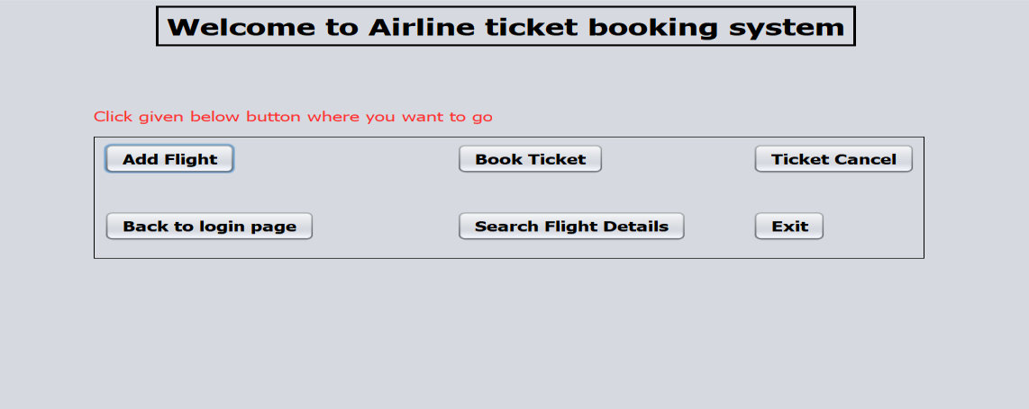

**LOGINPAGE**

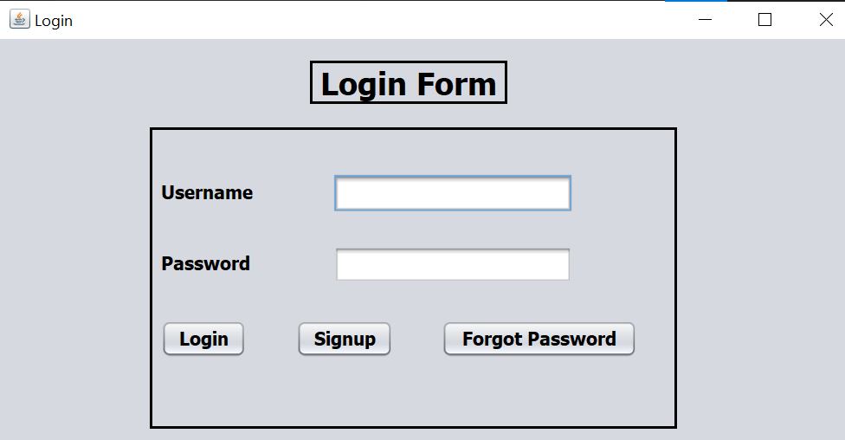

**SIGNUPPAGE**

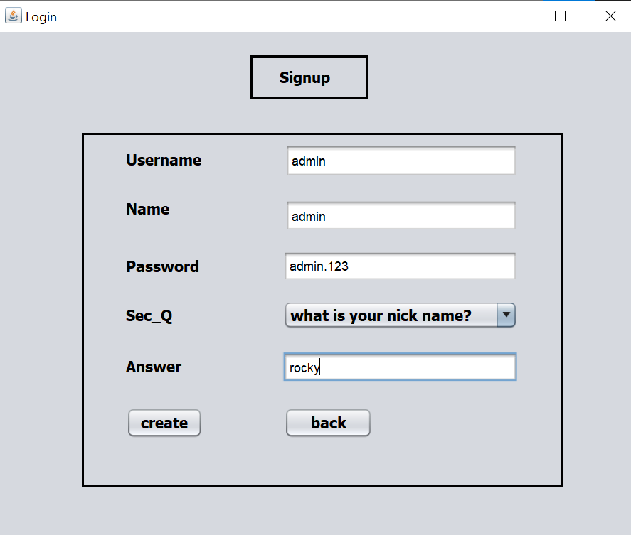

**FLIGHTTICKETBOOKINGPAGE**

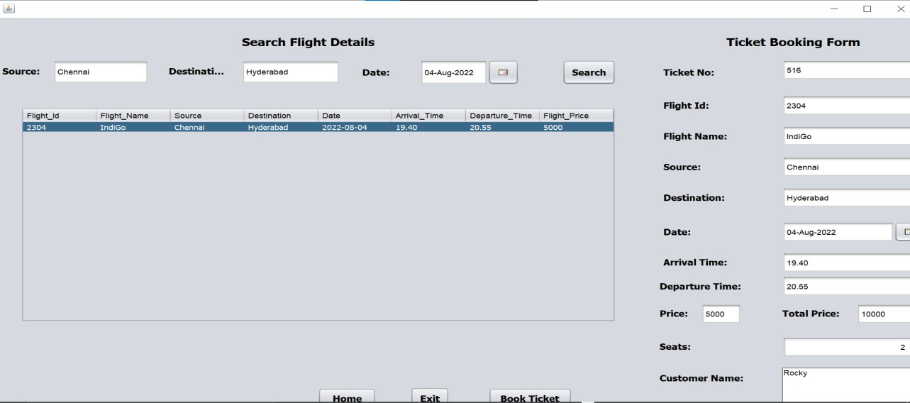

**PAYMENT PAGE**

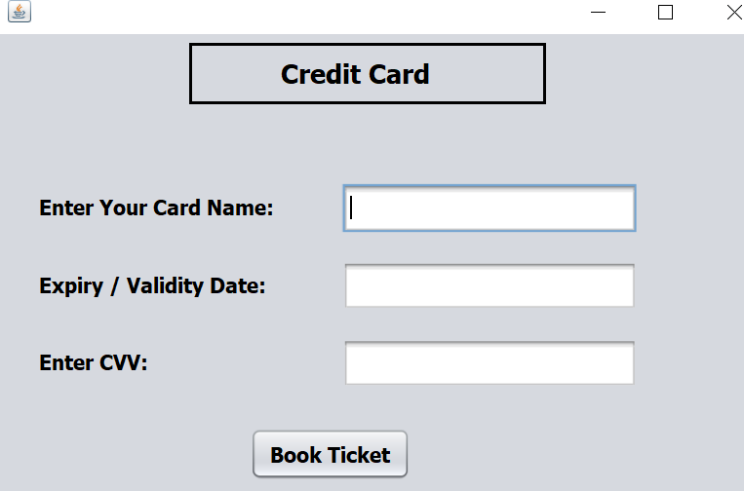

**FLIGHTTICKETCANCELLATIONPAGE**

